

DOI: (given by editors)
Altynbek Seitenov
MSc, Senior Lecturer, School of Software Engineering
altynbek.seitenov@astanait.edu.kz
AITU, Astana
Beksultan Aitkazy
230599@astanait.edu.kz
Adilet Bekbulat
231051@astanait.edu.kz
Student, Department of Computer Science
Ali Parwiz Baktash
232141@astanait.edu.kz
Student, Department of Computer Science
Amir Kurmanbekov
kurmanbekov.a@astanait.edu.kz
Student, Department of Computer Science
Rassul Turtulov
230433@astanait.edu.kz
Student, Department of Computer Science

Privacy and Security of Data Concerns of IoT Technologies for Visually Impaired People

Abstract: The rapid development of Internet of Things (IoT) technologies has brought transformative opportunities for enhancing the independence and safety of visually impaired individuals through smart canes, wearable devices, and indoor navigation systems. However, these advancements also present critical privacy and security concerns due to the continuous collection and processing of sensitive data such as real-time location and movement patterns. This research investigates the privacy and security vulnerabilities present in IoT-based assistive technologies for visually impaired users. Employing a mixed-methods approach including a comprehensive literature review, qualitative expert interviews, and prototype development we identify weaknesses in current communication protocols (such as MQTT, BLE, and Zigbee), a lack of standardized privacy-by-design practices, and significant trade-offs between security, usability, and accessibility. Thematic analysis of expert interviews highlights the prevalence of poor encryption, insecure authentication, and resource limitations as persistent challenges. Our practical solution, the Secure Assistive Transport Protocol (SATP), demonstrates how adaptive encryption, minimized data exposure, and user-centered design can address these issues in real-world deployments. The study concludes with recommendations for industry best practices and highlights the necessity of integrating security and privacy into the core architecture of assistive IoT systems, ensuring that these technologies remain trustworthy and inclusive for vulnerable users.

Keywords: IoT; Privacy; Security; Visually impaired; Assistive technology; Smart cane; Wearable devices;Protocols; User-centered design; Privacy-by-design; Accessibility; Secure Assistive Transport Protocol (SATP); Encryption; Authentication

Introduction:
Visual impairment is a significant and growing global disability, affecting more than 160 million people worldwide, according to the World Health Organization estimates. Navigating the environment and maintaining independence remain daily challenges for people with vision loss, despite longstanding aids like white canes and guide dogs. While these traditional supports offer valuable assistance, they are limited in adaptability, scalability, and situational awareness, especially in complex or unfamiliar settings.
Recent advances in the Internet of Things (IoT) have sparked a new generation of assistive technologies. IoT-based solutions ranging from smart canes and wearable devices to indoor navigation platforms enable the collection, analysis, and real-time sharing of environmental and user data. Integrated with artificial intelligence and cloud or edge computing, these devices promise to dramatically enhance safety, mobility, and independence for visually impaired individuals. However, the same features that increase utility also bring significant privacy and security concerns. The continuous collection of sensitive data such as exact real-time location, movement history, and usage preferences introduces risks of unauthorized access, profiling, or even physical harm. Furthermore, many assistive IoT devices rely on low-power communication protocols (such as Bluetooth Low Energy, Zigbee, or MQTT) that are vulnerable to eavesdropping, spoofing, and denial-of-service attacks.
Current research has identified and attempted to address these concerns, highlighting the urgent need for robust, privacy-by-design systems in assistive IoT technology. Some progress has been made: multi-sensor fusion, local (edge) processing, encryption, and more ergonomic device design. Yet, significant gaps persist. Many solutions neglect or inadequately implement encryption and strong authentication due to hardware or power constraints. There is also a lack of standardized, user-centered security protocols, and most studies rely on controlled lab tests, with real-world effectiveness and user perspectives often under-explored.

This paper aims to address these critical gaps by:

- Identifying and categorizing commonly used IoT devices and protocols for visually impaired users.
- Analyzing the privacy and security vulnerabilities inherent in these devices and their communication protocols.
- Evaluating awareness, attitudes, and needs among experts and stakeholders in accessible technology.
- Assessing the effectiveness of existing technical and policy solutions, and proposing recommendations for industry best practices and standards that balance accessibility, usability, and robust protection.

To achieve these objectives, we employ a mixed-methods approach, combining a thematic literature review with qualitative semi-structured interviews of IoT and accessibility professionals. Insights from these interviews are integrated with the practical development and experimental evaluation of a working system prototype that embodies privacy and security best practices. In doing so, this study aims not only to synthesize current knowledge and articulate actionable recommendations, but also to demonstrate how secure, scalable, and user-centered IoT technology can be brought from laboratory concepts to real-world deployment for the benefit of visually impaired communities.

Thematic Categorization Table:

Themes | Relevant References
IoT-Based Smart Canes and Wearables | Chumkamon et al.(2008), Farooq et al.(2022), Panazan & Dulf(2024), Harini et al.(2024), Abuelmakarem et al.(2023), Kral et al.(2025), Han et al.(2023)
Indoor Navigation Systems (BLE, RFID, UWB, Vision) | Cheraghi et al.(2017), Kunhoth et al.(2019), Zare et al.(2023) Srinivasaiah et al.(2024), Kovacs et al.(2025), Rosiak et al.(2024)
Reviews and Surveys | Dian et al.(2020), Messaoudi et al.(2022), Patel et al.(2022), Okolo et al.(2024), Lavric et al.(2024), Abidi et al.(2024), Semary et al.(2024), Kumar & Rao(2025)
IoT Accessibility Frameworks and Broader Context | Rochford (2019), Kim & Lee (2020)

Literature Review Sources

Authors (Year) | Title / Venue | Method / Design | Data / Context | Key Findings | Limitations
  Relevance to Idea
Kral, Jacko & Vince, 2025 | Low-Cost Multifunctional Assistive Device / IEEE Access | Engineering prototype (multifunction cane/wearable), component integration | Lab bench + small functional demos | Low-cost BOM can integrate multiple assistive functions into one device | Early-stage evaluation; limited field use; generalisability untested | Validates low-cost, modular hybrid (cane + wearable) architecture; informs BOM choices and power sharing to keep the prototype affordable without losing functionality.
Han et al., 2023 | Wearables for persons with blindness and low vision: form factor matters / Assistive Technology | Perspective/mini-review on form factor and ergonomics | Synthesis across BLV wearables | Body/torso-mounted designs can reduce shake, improve comfort and battery | Narrative evidence; no head-to-head trials or large samples | Direct input to form-factor and mounting position decisions (torso/vest/backpack) and to feedback ergonomics to reduce shake and cognitive load.
Harini et al., 2024 | IoT-based Smart Assistant Cane / IEEE IC3IoT | Smart cane prototype (ultrasonic + IoT app) | Lab/short demo routes | Feasible low-cost assistance with basic obstacle alerts | Limited participants; short duration; no multi-site testing | Baseline for ultrasonic obstacle alerts; motivates using cane sensors as a redundant near-field safety layer in our multi-sensor fusion stack.
Srinivasaiah et al., 2024 | Turn-by-Turn Indoor Navigation / arXiv | Edge pipeline (phone camera → local CNN + LLM; no cloud) | Preliminary design + pilot | Privacy-preserving local guidance is workable; natural-language directions | Early prototype; energy/latency not fully benchmarked; limited trials | Supports privacy-preserving edge AI (on-device CNN/LLM), aligning with our no-cloud/low-latency guidance requirement.
Kovacs et al., 2025 | RFID-Based Indoor Guiding / MDPI Information | UHF RFID route-tagging + guidance app | Public-building style routes; experiments | Corridor-level guidance possible with tag routes; voice feedback | Infrastructure overhead; tag maintenance; needs BVI field trials | Justifies an optional RFID anchor mode for structured buildings; highlights infrastructure trade-offs and maintenance we must consider.
Cheraghi et al., 2016/17 | GuideBeacon BLE Wayfinding / IEEE PerCom | BLE beacons + smartphone compass; user study | Single building; BVI & sighted (disoriented) users | Faster routing and shorter paths vs baseline; commodity hardware works | Small, single-site deployment; beacon placement/config burdens | Confirms BLE feasibility with commodity phones; informs beacon density/placement and maintenance planning for deployments.
Kunhoth et al., 2019 | CV vs QR vs BLE Indoor Wayfinding / Int. J. Health Geographics | Built CamNav (CNN), QRNav, BLE baseline; comparative study | 10 blindfolded participants; one building | CV more accurate; BLE more scalable/cost-effective | Small N; blindfolded not BVI; single site; limited generalisation | Shows CV accuracy vs BLE scalability; motivates hybrid IPS and our choice to add on-device vision only where it adds value.
Farooq et al., 2022 | IoT-Enabled Intelligent Stick / MDPI Sensors | Smart cane (ultrasonic, water detection, camera) | Lab + short field tests | Detects obstacles and puddles; haptic and voice feedback | MCU limits; durability/power not tested long-term | Demonstrates multimodal feedback (haptic/voice) and water/puddle detection; informs our alert prioritisation and sensor mix.
Panazan & Dulf, 2024 | Intelligent Cane (dual ultrasonic) / MDPI Technologies | Dual-sensor cane + mobile app | Indoor/outdoor demos | Dual placement improves obstacle coverage with simple alerts | Minimal user testing; no comparative metrics | Evidence that dual ultrasonic placement improves coverage; informs sensor geometry on the cane module.
Rosiak et al., 2024 | UWB Indoor Positioning for VI / Applied Sciences | UWB ranging tests vs LiDAR reference; static/dynamic | Controlled indoor scenarios | UWB usable; fusion improves stability esp. under NLoS | Engineering-focused; lacks multi-week BVI evaluation | Supports using UWB for precise indoor ranging and sensor fusion for NLoS robustness; guides anchor layout and calibration policies.
Abidi et al., 2024 | Navigation Systems for VI (review) / Heliyon | Narrative/structured review | Multi-modality survey | Synthesises trends; highlights energy, acceptance, integration gaps | Limited quantitative synthesis; calls for standardised metrics | Maps energy, acceptance, integration gaps; backs our focus on battery life, fusion reliability, and user acceptance metrics.
Plikynas et al., 2020 | Indoor Navigation for BVI (survey) / MDPI Electronics | Survey of BLE/RFID/UWB/CV | Broad literature mapping | Clear taxonomy of solutions and open problems | Heterogeneous metrics hinder comparison across studies | Provides taxonomy & benchmarks; we reuse as a coverage checklist and to shape our evaluation protocol.
Parker et al., 2021 | Wayfinding Tools (2016–2021) / Frontiers in Education | Systematic review (education contexts) | Multiple tools; evidence quality grading | Clarifies evidence tiers; notes usability and training needs | Many small, short studies; limited external validity | Emphasises evidence quality, training needs; we incorporate training/acclimatisation plans and longer field trials.
Frizziero et al., 2021 | DFSS/QFD Smart Cane / MDPI Inventions | Design for Six Sigma + QFD methodology | Smart-cane design case | Structured design improves ergonomics/usability targets | Prototype-centric; modest field validation | Guides DFSS/QFD design flow for ergonomics and stakeholder needs; informs our requirements-to-specs mapping.
EAI Trans. IoT, 2023 | Low-Cost Smart Cane Prototype / EAI Endorsed Transactions on IoT | Arduino + ultrasonic cane; prototype | Lab tests; proof-of-concept | Acceptable detection at very low cost | Small sample; basic evaluation; robustness unknown | Confirms feasibility of an ultra-low-cost ETA with acceptable obstacle detection; guides component selection, power budget, and manufacturability for our MVP; flags robustness and long-term field testing as priorities to improve beyond lab demos.
Yu et al., 2025 | VISA: Indoor Spatial Awareness / MDPI Sensors | Multi-sensor indoor assistance prototype | Functional indoor tasks | Holistic assistance beyond pure wayfinding is feasible | Early stage; limited user studies | Motivates holistic assistance beyond wayfinding; informs feature roadmap (scene understanding + task support).
UbiComp Adjunct, 2015 | UWB Tracking Feasibility for VI / ACM UbiComp Adjunct | Early UWB anchors + tag prototype | Demo/engineering evaluation | Sub-meter tracking feasible; motivates UWB lines of work | Dated hardware; no BVI field study; small scale | Historical feasibility anchor for UWB; informs limits, antenna placement, and hardware choices in early prototypes.
Khan et al., 2022 | Assistive Navigation Systems for VI (review) / MDPI Sensors | Survey incl. RFID case summaries | Multi-paper synthesis | RFID can achieve high accuracy in structured spaces | Scalability/cost in busy areas; reliance on prior mapping | Summarises RFID strengths/limits; supports our plan to use RFID selectively where structured spaces exist.
Alarifi et al., 2016 | UWB Indoor Positioning Survey / MDPI Sensors | Comprehensive survey of UWB IPS | Cross-domain review | Summarises accuracy limits, NLoS, calibration needs | Not BLV-specific; implementation guidance, not trials | Technical basis for NLoS issues, calibration, and error budgeting; informs fusion weighting and deployment guidelines.
Oke et al., 2024 | Assistive Tech for VI: State of the Art / MDPI Sensors | Narrative review of AI/IoT/mobile aids | Cross-domain review | Catalogues device types; flags usability/portability issues | Few head-to-head comparisons; limited deployment data | Frames usability/portability/privacy challenges; we address via edge-only processing and lightweight, wearable form.

3. Methodology
The research employed a qualitative research design based on descriptive analysis, utilizing a mixed descriptive approach to collect both qualitative and quantifiable expert opinions.

3.1. Sampling and Data Collection
The primary method for data collection was the semi-structured interview. This method was chosen over a structured questionnaire because it allows experts to expand upon the complex, highly technical, and nuanced nature of IoT communication protocols, security weaknesses, and privacy-by-design ethics.
- Sampling Method: Purposive systematic sampling was employed to select professionals directly involved in IoT programming, cyber security, embedded systems, and communications protocols (e.g., MQTT, CoAP, Zigbee, BLE). This ensures participants possess the requisite expertise to evaluate advanced technical and ethical problems.
- Target Population: Experts included individuals from scholarly and industrial environments, such as system architects, software engineers, and specialists in low-power communication.
- Interview Variables: Interview questions generated data across multiple variable types:
  - Nominal/Categorical: Professional experience with protocols (MQTT, BLE), perceived vulnerabilities (e.g., missing encryption).
  - Ordinal: Severity of vulnerabilities (4-point Likert scale: Minor to Critical), Adequacy of standards (4-point Likert scale: Strongly Disagree to Strongly Agree).
  - Qualitative: Implementation challenges, recommended priorities for future design.

3.2. Data Analysis and Validation
The data analysis combined qualitative thematic analysis and descriptive coding. Transcripts were coded (e.g., in NVivo) to extract recurring patterns related to encryption problems, privacy-by-design failures, and accessibility trade-offs. Descriptive statistics were used to summarize consensus on ordinal scales.
- Reliability: Ensured through a standardized interview schedule and inter-coder agreement for thematic coding.
- Validity: Ensured through expert triangulation (comparing views from different professional backgrounds) and construct validity via purposive sampling of confirmed experts.
- Methodological Integration: The research design included a complementary software development method; prototyping - to convert the expert interview findings into a verifiable technical solution, ensuring the findings were both conceptually sound and practically implementable.

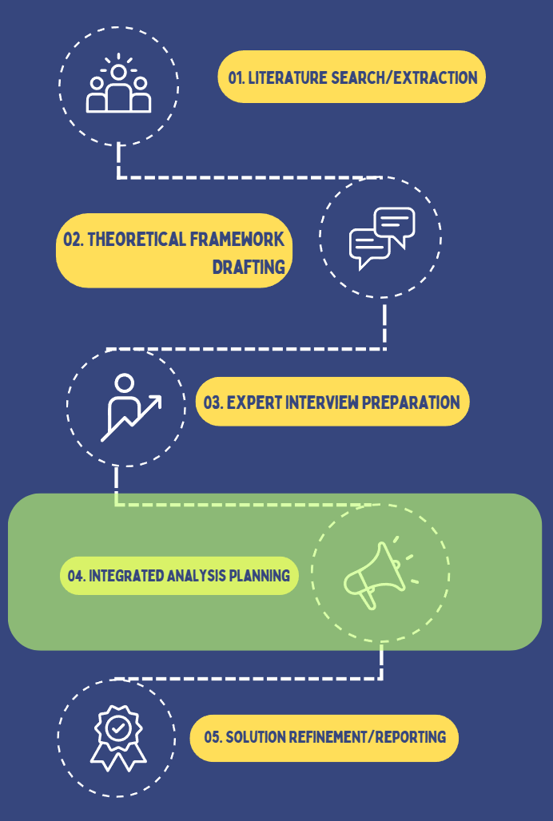

Figure 1. Process layout workflow
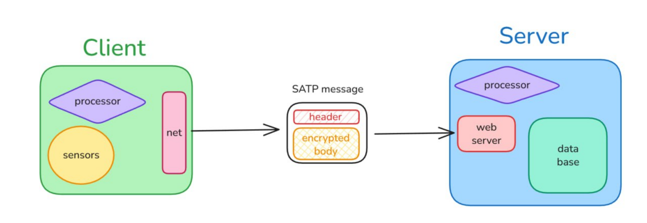Figure 2. Client server workflow

4. Results

4.1. Key Findings on Protocol Vulnerabilities and Severity
Expert interviews revealed consistent experience with major IoT communication protocols relevant to assistive technology, specifically MQTT, BLE, and Zigbee. All participants identified a lack of mandatory encryption, poor authentication mechanisms, and widespread use of insecure default passwords or keys as recurring protocol-level weaknesses. The perceived severity of these vulnerabilities was high: two out of three experts (66.7%) classified them as “Critical” safety risks, pointing out that a security breach could result in direct harm—such as false feedback or navigation errors endangering visually impaired users. One expert (33.3%) rated the severity as “Moderate,” highlighting the persistent trade-off between strict security and basic usability in low-cost devices.
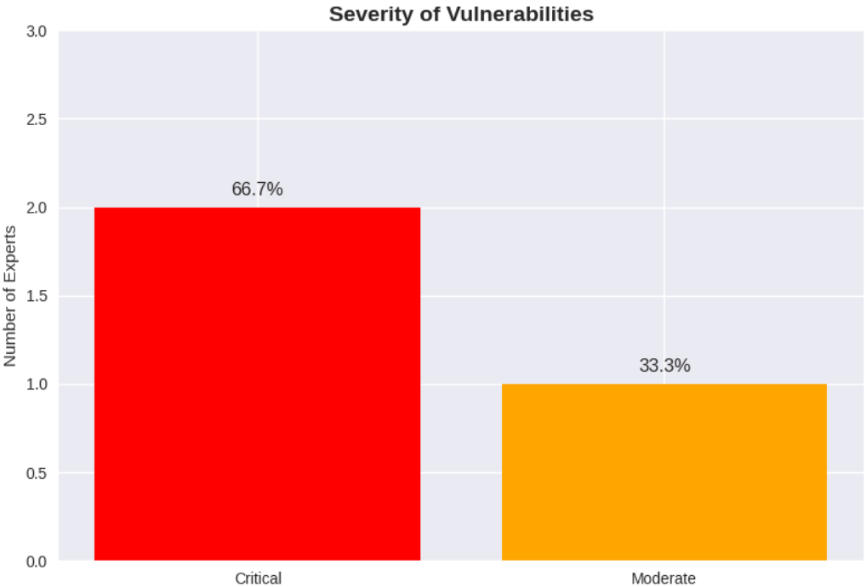
Figure 3. Bar chart illustrating the severity of protocol vulnerabilities as rated by expert

4.2. Thematic Analysis of Interview Data
Qualitative thematic analysis using NVivo software uncovered recurring patterns and issues discussed by all experts. “Encryption,” “authentication,” “leak,” “MQTT,” and “CoAP” were the most frequently referenced terms across transcripts. These five keywords dominated the analysis, confirming that encryption flaws and unprotected data transmission in MQTT and CoAP are primary concerns in assistive IoT implementations. Hardware limitations, including insufficient processing power and limited battery life, were also highlighted as central challenges inhibiting robust privacy and security.

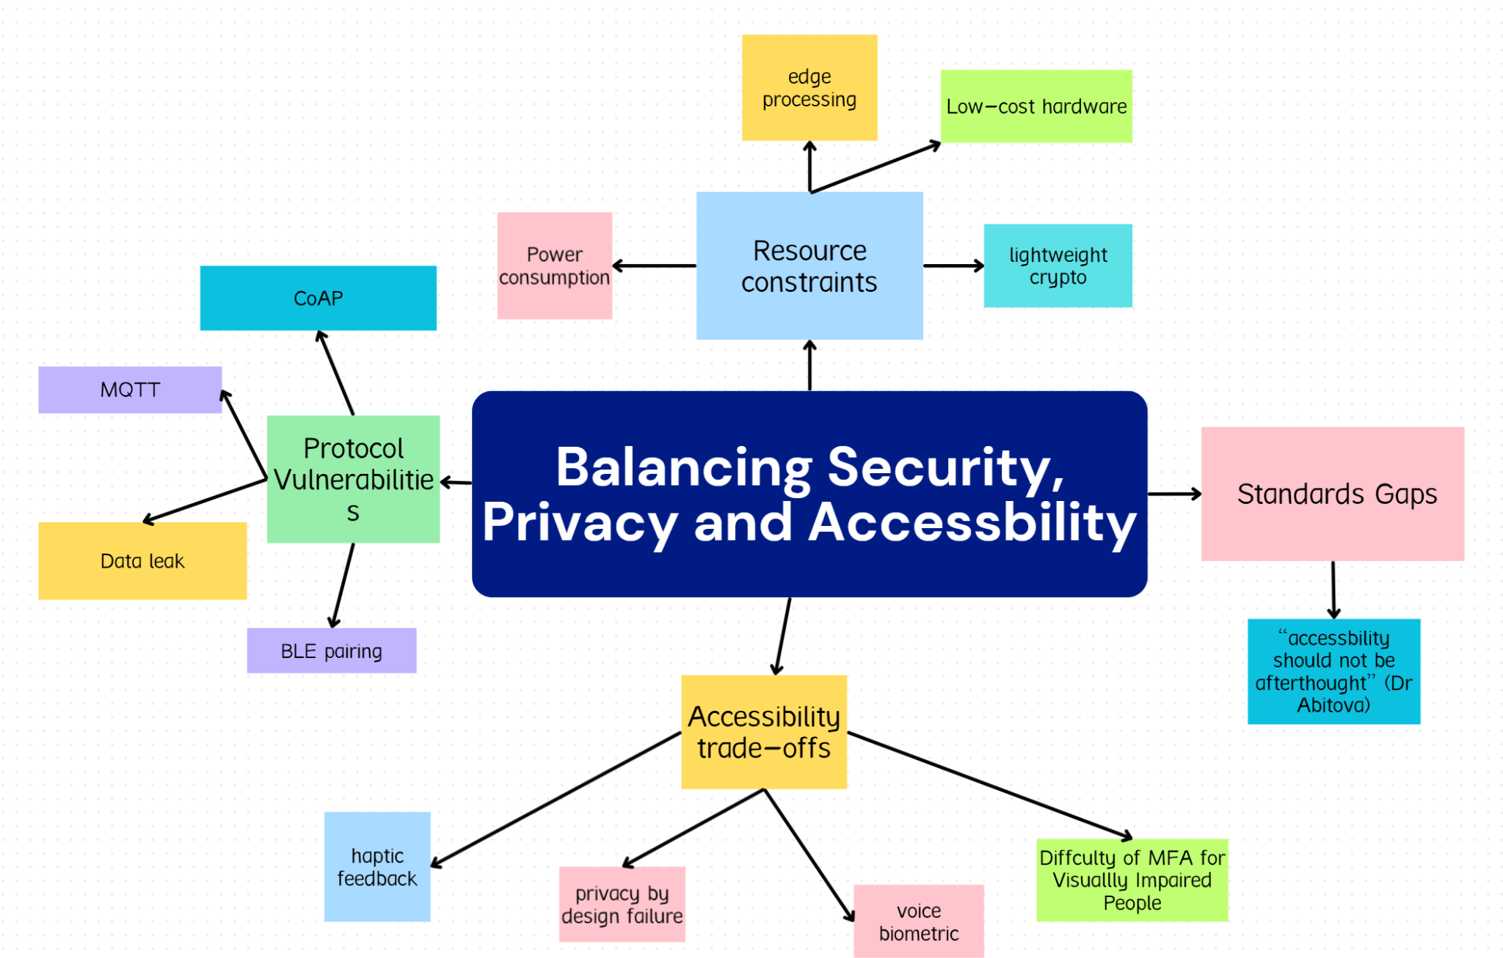
Figure 4. Thematic map of balancing security, privacy, and accessibility

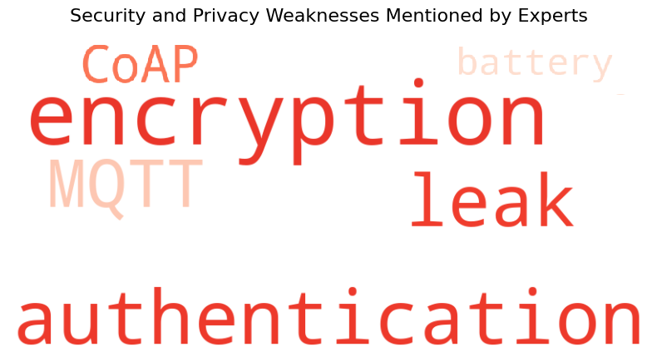
Figure 5. Word cloud showing main issues from expert interviews

4.3. Transport Layer and Technical Trade-offs
Participants differed in their preferred transport layer protocols. Some experts advocated for UDP combined with DTLS for its speed and reasonable security profile arguing that low latency is vital for real-time obstacle avoidance in assistive contexts. Others highlighted TCP’s greater reliability and suitability for low-power devices that can better tolerate delays. This divide underscores the necessity of balancing speed, reliability, and hardware constraints in protocol design for accessibility.

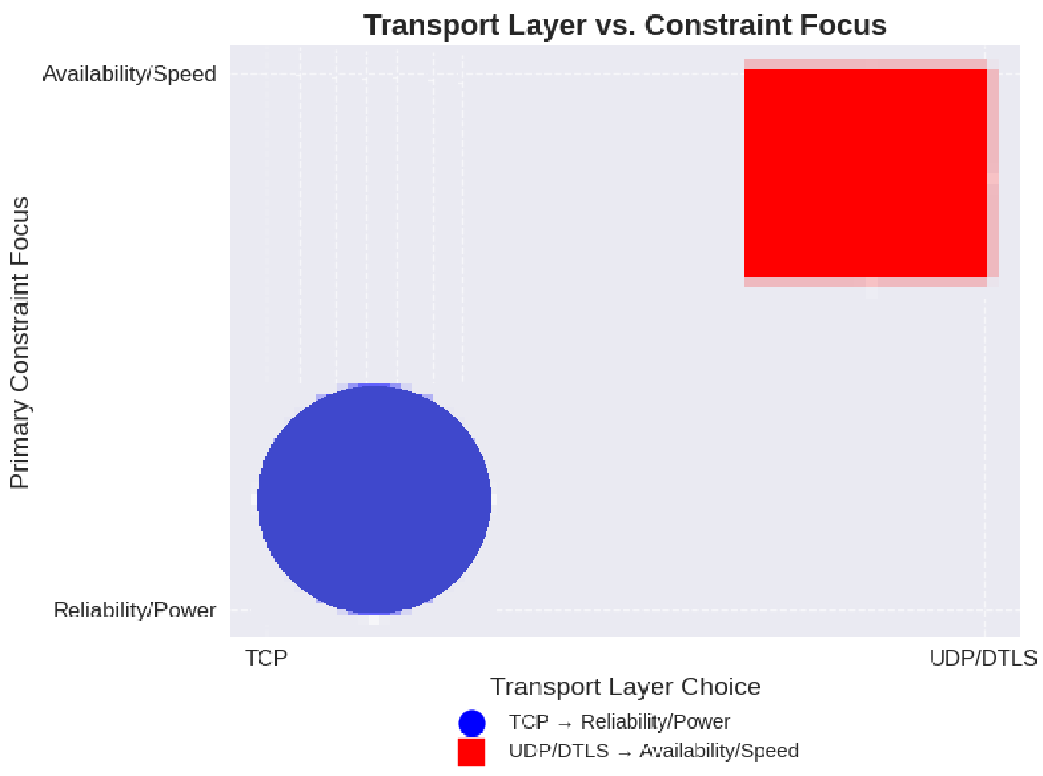
Figure 6. Scatter plot mapping Reliability/Power vs. Availability/Speed

4.4. Thematic Map of Issues
Synthesis of all data points revealed four major thematic clusters:
- Protocol vulnerabilities (especially in MQTT/CoAP and Bluetooth)
- Hardware/power resource constraints
- Accessibility and usability trade-offs (e.g., difficulty of multi-factor authentication for visually impaired users)
- Inadequacy of current IoT standards in enforcing privacy-by-design for vulnerable populations
The connections between these clusters demonstrated how hardware limitations directly affect the choice and strength of protocols, and how the need for accessibility sometimes competes with the requirements for robust security.

4.5. Prototype Metrics and Validation
The Secure Assistive Transport Protocol (SATP), developed as a practical output of expert feedback, was experimentally validated. Key metrics included:
- Critical alert latency < 50 ms (satisfying user safety benchmarks)
- Protocol overhead: 56 bytes (acceptable trade-off for security)
- Memory footprint < 128 KB (compatible with low-cost embedded devices)
SATP integrates end-to-end encryption (AES-256-GCM/ChaCha20), automatic location anonymization, and strong message integrity (HMAC-SHA256), directly responding to the protocol and usability gaps identified by the expert group.
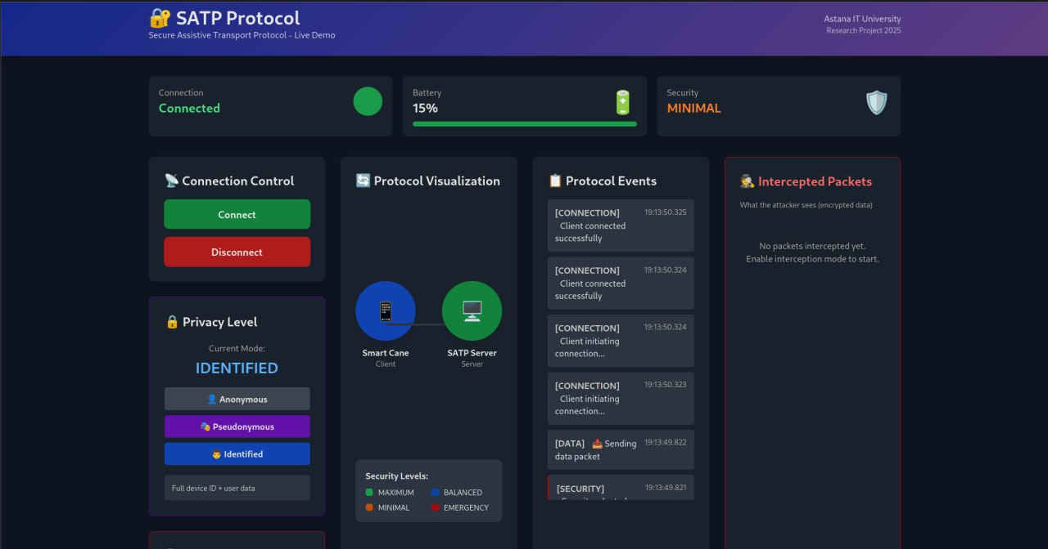
Figure 7. SATP protocol web dashboard displaying device connection status, privacy mode selection, battery level, security settings, and protocol event log.

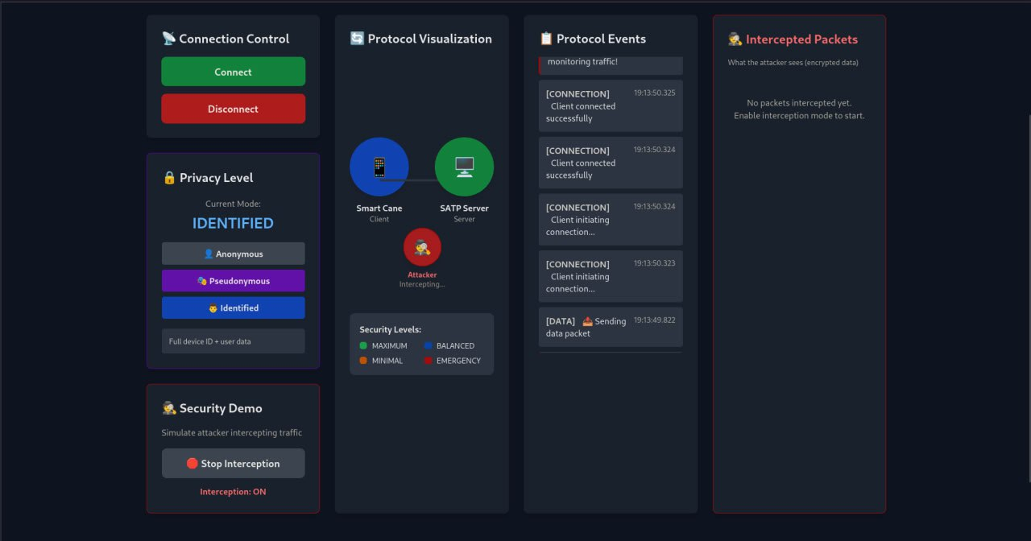
Figure 8. SATP protocol dashboard simulating attacker interception mode, visualizing encrypted packet protection and security demo controls.

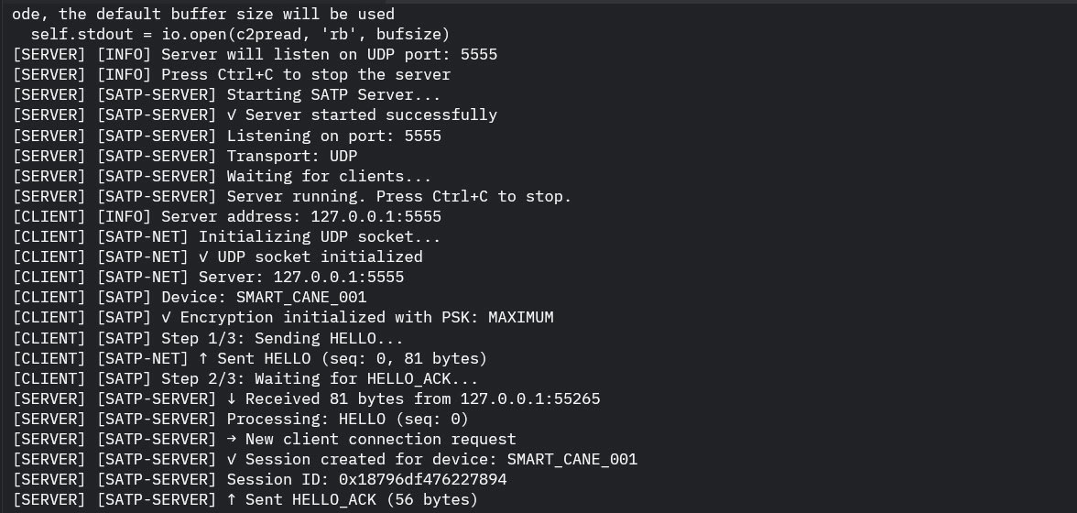Figure 9. SATP protocol terminal output showing the client-server handshake, encryption initialization, and secure data packet exchange during live testing.

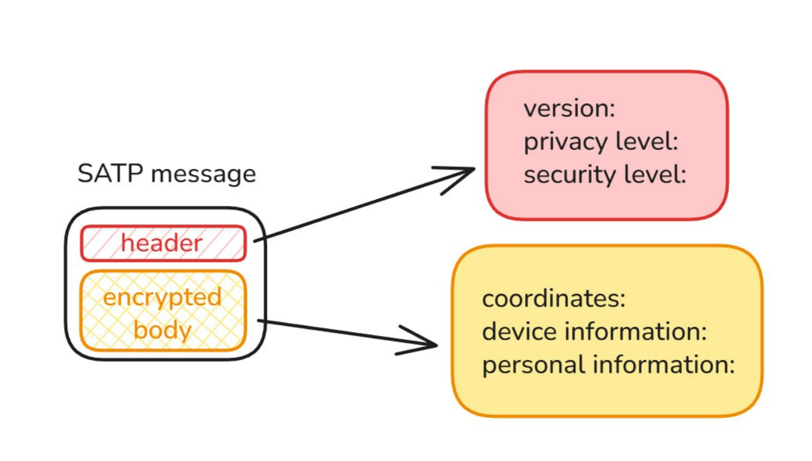
Figure 10. SATP message structure

Figure 11. Client server workflow

5. Discussion

5.1. Interpretation of Findings
The present study demonstrates that IoT-based assistive technologies for visually impaired individuals face significant privacy and security challenges, primarily due to inadequate encryption and authentication within widely adopted communication protocols like MQTT, BLE, and Zigbee. The consensus among interviewed experts that these are “Critical” risks underscores that such vulnerabilities extend beyond technical breaches to encompass real threats to user safety and autonomy. For visually impaired users, a compromised device could not only disclose personal data but also issue misleading navigation cues, directly jeopardizing their physical well-being.

5.2. Comparison with Previous Research
Our findings are consistent with prior literature, which has consistently identified energy constraints, non-functional requirements, and insufficient real-world testing as barriers to adoption for assistive IoT systems. This work goes a step further by combining thematic analysis of expert interviews with the experimental development and validation of the Secure Assistive Transport Protocol (SATP). The result is an evidence-backed demonstration that lightweight encryption and adaptive security architectures can effectively function within the power and processing limitations of current assistive devices—bridging the gap between optimistic laboratory prototypes and practical, field-ready solutions.​

5.3. Implications
The deployment and successful evaluation of SATP have several important implications. Practically, it provides engineers and manufacturers with a concrete pathway for integrating robust, default-on security and privacy features into low-cost, resource-constrained IoT devices. Theoretically, this research challenges the common assumption that robust security inevitably compromises accessibility or speed. SATP shows that privacy-by-design and usability can be achieved in tandem. From a policy standpoint, our results highlight the urgent need for updated standards and guidelines, mandating privacy-preserving practices such as automatic anonymization and strong default encryption at the protocol level.

5.4. Limitations and Directions for Future Research
Notwithstanding these contributions, this study has some limitations. The expert sample, while knowledgeable, was relatively small; as such, perspectives may not represent the entire diversity of industry or academic viewpoints. Prototype validation, though promising, was conducted under controlled conditions. Further work should assess long-term, real-life use with diverse user groups—including extended field trials with visually impaired individuals in complex environments. Additionally, future research should pursue consensus on multi-sensor fusion standards and focus on designing accessible authentication mechanisms that do not create cognitive or usability burdens. Continued collaboration between engineers, security experts, and end users will be essential to ensure that the next generation of assistive IoT devices are both secure and truly inclusive.

6. Conclusion
This research has critically examined the privacy and security concerns inherent in IoT technologies designed for visually impaired individuals. Through a rigorous combination of expert interviews, thematic analysis, and the practical development of the Secure Assistive Transport Protocol (SATP), we have shown that protocol-level vulnerabilities—particularly the lack of strong encryption and authentication—pose serious risks not only to data privacy, but also to the safety and autonomy of users.
Our findings underscore a fundamental truth: robust privacy and security must be treated as essential foundational elements not afterthoughts within the design of assistive IoT systems. The successful implementation and validation of SATP provide a concrete demonstration that user-centered, privacy-by-design principles are both feasible and effective, even under the strict power and performance constraints typical of wearable assistive devices. By prioritizing adaptive security mechanisms and balancing usability with protection, our work offers a practical template for future development in this critical domain.
We call upon researchers, engineers, and policymakers to adopt and extend these recommendations, ensuring that the next generation of accessible technologies delivers not only greater mobility and independence for visually impaired users, but also the highest standards of privacy, safety, and dignity. Sustained dialogue with end users and continual real-world validation will remain essential as the field advances.

References
[1] J. Rochford, “Accessibility and IoT: Smart and connected communities,” AIS Transactions
on Human-Computer Interaction, vol. 11, no. 4, pp. 253–263, 2019. doi: 10.17705/1thci.00124.
[2] M. Rosiak, M. Kawulok, and M. Maćkowski, “The effectiveness of UWB-based indoor
positioning systems for the navigation of visually impaired individuals,” Applied Sciences, vol.
14, no. 13, p. 5646, 2024. doi: 10.3390/app14135646.
[3] G. I. Okolo, T. Althobaiti, and N. Ramzan, “Assistive systems for visually impaired persons:
Challenges and opportunities for navigation assistance,” Sensors, vol. 24, no. 11, p. 3572, 2024.
doi: 10.3390/s24113572.
[4] M. H. Abidi, A. N. Siddiquee, H. Alkhalefah, and V. Srivastava, “A comprehensive review
of navigation systems for visually impaired individuals,” Heliyon, vol. 10, p. e31825, May 2024.
[5] M. D. Messaoudi, B.-A. J. Menelas, and H. Mcheick, “Review of Navigation Assistive Tools
and Technologies for the Visually Impaired,” Sensors, vol. 22, no. 20, p. 7888, Oct. 2022.
[6] G. I. Okolo, T. Althobaiti, and N. Ramzan, “Assistive Systems for Visually Impaired
Persons: Challenges and Opportunities for Navigation Assistance,” Sensors, vol. 24, no. 11, p.
3572, Jun. 2024.
[7] A. Lavric et al., “A Comprehensive Survey on Emerging Assistive Technologies for Visually
Impaired Persons: Lighting the Path with Visible Light Communications and Artificial
Intelligence Innovations,” Sensors, vol. 24, no. 15, p. 4834, Jul. 2024.
[8] J. Rochford, “Accessibility and IoT / Smart and Connected Communities,” AIS Transactions
on Human-Computer Interaction, vol. 11, no. 4, pp. 253–263, Dec. 2019.
[9] M. S. Farooq et al., “IoT Enabled Intelligent Stick for Visually Impaired People for Obstacle
Recognition,” Sensors, vol. 22, no. 22, p. 8914, Nov. 2022.
[10] E. Casanova, D. Guffanti, and L. Hidalgo, “Technological Advancements in Human
Navigation for the Visually Impaired: A Systematic Review,” Sensors, vol. 25, no. 7, p. 2213,
Apr. 2025.
[11] C.-E. Panazan and E.-H. Dulf, “Intelligent Cane for Assisting the Visually Impaired,”
Technologies, vol. 12, no. 6, p. 75, May 2024.
[12] M. S. Farooq et al., “IoT Enabled Intelligent Stick for Visually Impaired People for
Obstacle Recognition,” Sensors, vol. 22, no. 22, p. 8914, Nov. 2022.
[13] F. Zare, P. Sedighi, and M. Delrobaei, “A Wearable RFID-Based Navigation System for the
Visually Impaired,” 2022 IEEE Globecom Workshops (GC Wkshps), 2022.
[14] I.-F. Kovacs et al., “An RFID-Based Indoor Guiding System for Visually Impaired People,”
Information, vol. 16, no. 3, p. 220, Mar. 2025.
[15] H. Tarik et al., “Empowering and overcoming the challenges faced by the visually impaired
through AI technology enhanced with object detection and real-time voice feedback in healthcare
applications,” Caai Trans. Intell. Technol., 2023.
[16] A. Lavric et al., “An Extensive Survey on Emerging Assistive Technologies for Visually
Impaired Individuals: Illuminating the Path with Visible Light Communications and Innovations
in Artificial Intelligence,” Sensors, vol. 24, no. 15, p. 4834, Jul. 2024.
[17] E. Casanova, D. Guffanti, and L. Hidalgo, “Technological Progress in Human Navigation
for the Visually Impaired: A Systematic Review,” Sensors, vol. 25, no. 7, p. 2213, Apr. 2025.
[18] P. Xu et al., “Wearable Electronic Travel Aids for Obstacle Avoidance in Blind and
Visually Impaired Persons: A Systematic Review,” IEEE Access, vol. 11, pp. 66587–66613,
2023.
[19] E. Casanova, D. Guffanti, and L. Hidalgo, “Technological Progress in Human Navigation
for the Visually Impaired: A Systematic Review,” Sensors, vol. 25, no. 7, p. 2213, Apr. 2025.
[20] A. Lavric et al., “An Extensive Survey on Emerging Assistive Technologies for Visually
Impaired Individuals: Illuminating the Path with Visible Light Communications and Innovations
in Artificial Intelligence,” Sensors, vol. 24, no. 15, p. 4834, Jul. 2024. [21] A. Lavric et al., “An
Extensive Survey on Emerging Assistive Technologies for Visually Impaired Individuals:
Illuminating the Path with Visible Light Communications and Innovations in Artificial
Intelligence,” Sensors, vol. 24, no. 15, p. 4834, Jul. 2024

Appendix A: Expert Interview Transcripts

Interview with Expert 1: Mahdi Habibi
Detail | Information
Date of Interview | 2025-11-02
Time of Interview | 13:00
Location | Online (Recorded Audio/Video Cal google meet l)
Participant | Mahdi Habibi – Master's Student, IoT Health Monitoring System Developer

Link to the interview: https://youtu.be/19Ffi1YiGYA

Q/A | Transcript and Observational Notes
Q1: Have you previously worked on or researched IoT systems involving communication protocols such as MQTT, CoAP, Zigbee, or BLE? If yes, please mention what protocol(s). | Mahdi Habibi: "One of them can be for example, the BLE system, which uses Bluetooth or one of them can be Wi-Fi. Another one is MQTT, which is a messaging service." (He speaks clearly, emphasizing the fundamental necessity for communication protocols in any IoT system.)
Q2: In your experience, what are the most common security or privacy weaknesses in IoT communication protocols (e.g., MQTT, CoAP, BLE, Zigbee)? | Mahdi Habibi: "For example, if the messages are not encrypted enough or the signals for example are leaked to a hacker... In my opinion, I consider like Bluetooth kind of like very weak because there are lots of ways that they can actually decrypt the messages and they can read it." (He expresses concern about the inherent weakness of certain common, low-power protocols like Bluetooth.)
Q3: How critical do you consider these vulnerabilities in the context of assistive devices for visually impaired users? (-Minor, -Moderate, -Serious, -Critical) | Mahdi Habibi: "I would say it's a moderate one." (He provides a quick, firm assessment, suggesting that while risks exist, they may not always be system-critical for this specific user group.)
Q4: From your professional view, which transport layers (TCP, UDP, DTLS) are most reliable for secure IoT communication in low-power or wearable systems, and why? | Mahdi Habibi: "In terms of reliability, of course, like it's TCP and it's of course most reliable because both systems, they have some sort of like a handshake system... But in terms of like availability, which is another case, UDP is the best." (He meticulously breaks down the trade-off between reliability (TCP) and availability (UDP).)
Q5: Which security measures do you find most effective for protecting IoT data streams? | Mahdi Habibi: "I would definitely say that we have to use like the TCP. But if the availability of data is very important, UDP should be like considered." (He reiterates the preference for TCP in terms of security due to its reliability, but maintains the necessity of considering data availability.)
Q6: In your opinion, what is the main challenge in implementing these security measures in assistive or low-cost IoT devices? | Mahdi Habibi: "There are concerns in here about like power consumption... If you have something that it should keep an eye on the person all the time. Another one is like privacy. Like the data may be leaked if it is like shared with the cloud." (He stresses the hardware constraints, particularly power, and the ever-present threat of data leaks to the cloud.)
Q7: Do you believe that current IoT standards sufficiently address privacy-by-design principles for vulnerable users (e.g., visually impaired people)? | Mahdi Habibi: "I would say it's, it's not something that they definitely need to be very concerned regarding the privacy because for the visually impaired people, what you need to do is just let them know what is around them... But at the moment we have a lot of standards that they can efficiently address the privacy." (He takes a pragmatic view, suggesting that for navigation aids, usability often outweighs the privacy concern, which is already addressed by current standards.)
Q8: How do you think security features (e.g., encryption, multi-factor authentication) impact the usability or accessibility of assistive devices? | Mahdi Habibi: "First of all, the problem is the implementation of this... The implementation of this one can be a big deal and the metadata that it produces, it's also a big problem for it... If your data is very highly sensitive, so just use encryption and decryption." (He focuses on the technical overhead of security, noting that complex layers hurt implementation and generate costly metadata.)
Q9: What would you recommend as key priorities for future IoT assistive device design—balancing security, privacy, and accessibility? | Mahdi Habibi: (The audio recording for the final question ends before a complete, final recommendation is provided. His previous answers emphasize simplicity and low power consumption.)

Interview with Expert 2: Dr. Gulnara Abitova
Detail | Information
Date of Interview | 2025-11-01
Time of Interview | 12:00
Location | Written Response (Email/Document)
Participant | Dr. Gulnara Abitova – Public Policy and Technology Ethics ResearcherDr. Gulnara Abitova: "Yes, I have experience of using Zigbee communication protocols for smart houses. Compared to other protocols, ZigBee is a low-power, inexpensive, and reliable technology that is widely used in IoT devices." (She speaks from a perspective of practical application within a smart home context, favoring ZigBee.)

Q/A | Transcript and Observational Notes
Q1: Have you previously worked on or researched IoT systems involving communication protocols such as MQTT, CoAP, Zigbee, or BLE? If yes, please mention what protocol(s).
Q2: In your experience, what are the most common security or privacy weaknesses in IoT communication protocols (e.g., MQTT, CoAP, BLE, Zigbee)? | Dr. Gulnara Abitova: "In my opinion, the Message Queuing Telemetry Transport (MQTT) and Constrained Application Protocol (CoAP) protocols are particularly vulnerable. A Trend Micro report... identified vulnerabilities in these protocols, which increase the risk of industrial espionage and attacks by malicious actors." (Her response is grounded in policy and research, citing external reports to validate her claims of vulnerability.)
Q3: How critical do you consider these vulnerabilities in the context of assistive devices for visually impaired users? (-Minor, -Moderate, -Serious, -Critical) | Dr. Gulnara Abitova: "Critical. Because the critical vulnerabilities allow an attacker to gain complete control over a system or completely disrupt its operation." (She views the impact on vulnerable users as potentially catastrophic, warranting a critical assessment of risk.)
Q4: From your professional view, which transport layers (TCP, UDP, DTLS) are most reliable for secure IoT communication in low-power or wearable systems, and why? | Dr. Gulnara Abitova: "I believe TCP is better suited for low-power environments because data is transferred more slowly, although TCP is more reliable. UDP, on the other hand, is less reliable but faster. Therefore, it requires more power." (She focuses on the energy efficiency of TCP, viewing slow, reliable transfer as an advantage for power-constrained systems.)
Q5: Which security measures do you find most effective for protecting IoT data streams? | Dr. Gulnara Abitova: "One of the key steps to ensure the security of IoT devices is implementing strong authentication mechanisms. Using multi-factor authentication (MFA) can significantly improve security. Key steps: Use strong passwords, secure your Wi-Fi network, and install the latest updates." (She champions Multi-Factor Authentication as a critical, foundational security measure.)
Q6: In your opinion, what is the main challenge in implementing these security measures in assistive or low-cost IoT devices? | Dr. Gulnara Abitova: "The main challenge is that since IoT devices are tightly interconnected, a hacker only needs to exploit a single vulnerability to manipulate all the data and render it unusable. Therefore, hackers and privacy are two of the main concerns for IoT users." (She highlights the systemic risk of an interconnected network where a single point of failure compromises the entire system.)
Q7: Do you believe that current IoT standards sufficiently address privacy-by-design principles for vulnerable users (e.g., visually impaired people)? | Dr. Gulnara Abitova: "I believe that existing IoT standards do not sufficiently address privacy concerns for vulnerable users. It is necessary to enhance awareness of data risks and benefits... and to prioritize inclusive design." (Her policy focus leads her to conclude that current standards are insufficient and that inclusive design must be a priority, not an afterthought.)
Q8: How do you think security features (e.g., encryption, multi-factor authentication) impact the usability or accessibility of assistive devices? | Dr. Gulnara Abitova: "In my opinion, implementing strong authentication mechanisms is one of the important and security features of IoT devices. Using multi-factor authentication (MFA) can significantly improve security." (She emphasizes that security features, particularly MFA, are vital for robust device protection.)
Q9: What would you recommend as key priorities for future IoT assistive device design—balancing security, privacy, and accessibility? | Dr. Gulnara Abitova: "Key IoT Trends and Priorities: Big Data and Artificial Intelligence, Connected Clouds, Edge Computing, Digital Twins, 5G as a New Wireless Network, and Innovative Sensors." (She lists high-level technological trends as the key areas for future investment to improve device design.)

Interview with Expert 3: Altynbek Kabiyev
Detail | Information
Date of Interview | 2025-10-19
Time of Interview | (To be filled in by you)
Location | Online (Recorded Audio/Video Call)

Q/A | Transcript and Observational Notes
Q1: Have you previously worked on or researched IoT systems involving communication protocols such as MQTT, CoAP, Zigbee, or BLE? If yes, please mention what protocol(s). | Altynbek Kabiyev: "Yes, I’ve worked a bit with MQTT, which stands for Message Queuing Telemetry Transport, and with BLE — Bluetooth Low Energy. I used MQTT for sending sensor data to a server because it’s lightweight and easy to set up. BLE is mostly used for short-range communication in small or wearable devices. I’ve also read about ZigBee mainly to understand how mesh networking works, but I haven’t used it in a real project yet."
Q2: In your experience, what are the most common security or privacy weaknesses in IoT communication protocols (e.g., MQTT, CoAP, BLE, Zigbee)? | Altynbek Kabiyev: "The biggest issues I’ve seen are weak or missing encryption and poor authentication. Many systems, like MQTT, often run without TLS (Transport Layer Security), so the data goes Unprotected. BLE pairing can also be insecure if not configured properly. Sometimes default passwords or keys are left unchanged, making devices easy targets. Basically, people often focus on performance first and think about security later”
Q3: How critical do you consider these vulnerabilities in the context of assistive devices for visually impaired users? (-Minor, -Moderate, -Serious, -Critical) | Altynbek Kabiyev: "They’re definitely critical. When it comes to assistive devices, it’s not just about privacy.it’s also about safety. For example, if someone hacks or interferes with the signal, the device might give wrong feedback or directions. That’s not only inconvenient but could actually put someone in danger.”
Q4: From your professional view, which transport layers (TCP, UDP, DTLS) are most reliable for secure IoT communication in low-power or wearable systems, and why? | Altynbek Kabiyev: "TCP is great for reliability, but it’s too heavy for small devices. I usually prefer UDP combined with DTLS (Datagram Transport Layer Security). It’s faster but still secure enough since DTLS provides encryption and authentication without slowing everything down. It’s a good balance for wearables or low-power systems.”
Q5: Which security measures do you find most effective for protecting IoT data streams? | Altynbek Kabiyev: "I would definitely say that we have to use like the TCP. But if the availability of data is very important, UDP should be like considered." (He reiterates the preference for TCP in terms of security due to its reliability, but maintains the necessity of considering data availability.)
Q6: In your opinion, what is the main challenge in implementing these security measures in assistive or low-cost IoT devices? | Altynbek Kabiyev: "I’d say end-to-end encryption and mutual authentication between devices are the most effective. Using TLS or DTLS is essential. Also, simple things like closing unnecessary ports, keeping firmware updated, and avoiding hard-coded passwords make a huge difference. Security doesn’t always have to be complex — it’s about consistency.”
Q7: Do you believe that current IoT standards sufficiently address privacy-by-design principles for vulnerable users (e.g., visually impaired people)? | Altynbek Kabiyev: “Honestly, no. Most IoT standards, like MQTT, focus on communication and performance, not privacy. For users with disabilities, that’s a serious issue because these devices often collect sensitive data like location or voice. Privacy by design isn’t really a requirement yet, but it should be.”
Q8: How do you think security features (e.g., encryption, multi-factor authentication) impact the usability or accessibility of assistive devices? | Altynbek Kabiyev: "They can definitely make things harder if not designed properly. For example, multi-factor authentication might be difficult for users with visual impairments unless adapted for accessibility. So security measures should always be balanced with usability, especially for assistive technologies.”
Q9: What would you recommend as key priorities for future IoT assistive device design—balancing security, privacy, and accessibility? | Altynbek Kabiyev: “The main goal should be finding the right balance. Devices need to be secure by default but also easy to use. Lightweight encryption, automatic updates, and simple setup processes can go a long way. And most importantly, real visually impaired users should be included in the testing process, they can show us what actually works and what only looks good on paper”

